# **Build OpenCV 4 from source with Gstreamer**

*sudo apt update*

*sudo apt upgrade*

Now installing Gstreamer from terminal   
Ref: <https://gstreamer.freedesktop.org/documentation/installing/on-linux.html?gi-language=c>

*sudo apt-get install libgstreamer1.0-dev libgstreamer-plugins-base1.0-dev libgstreamer-plugins-bad1.0-dev gstreamer1.0-plugins-base gstreamer1.0-plugins-good gstreamer1.0-plugins-bad gstreamer1.0-plugins-ugly gstreamer1.0-libav gstreamer1.0-doc gstreamer1.0-tools gstreamer1.0-x gstreamer1.0-alsa gstreamer1.0-gl gstreamer1.0-gtk3 gstreamer1.0-qt5 gstreamer1.0-pulseaudio*

*sudo apt install libgstreamer1.0-dev libgstreamer-plugins-base1.0-dev*

*sudo apt install gstreamer1.0-tools*

*sudo apt-get install -y libavcodec-dev libavformat-dev libavutil-dev libswscale-dev libavresample-dev*

*sudo apt-get install -y pkg-config*

*sudo apt install libgtk-3-dev*

*sudo apt install libgtk2.0-dev*

*sudo apt-get install -y libdc1394-22-dev*

*conda create -n your_env_name python=3.x.x*

*conda activate your_env_name*

*pip install numpy*

Now get openCV repo in local machine.

*git clone* [*https://github.com/opencv/opencv.git*](https://github.com/opencv/opencv.git)

cd opencv/

git checkout 4.1.0

mkdir build

cd build

cmake -D CMAKE_BUILD_TYPE=RELEASE -D CMAKE_INSTALL_PREFIX=/usr/local INSTALL_PYTHON_EXAMPLES=ON -D INSTALL_C_EXAMPLES=OFF -D PYTHON_EXECUTABLE=$(which python3) -D BUILD_opencv_python2=OFF -D CMAKE_INSTALL_PREFIX=$(python3 -c "import sys; print(sys.prefix)") -D PYTHON3_EXECUTABLE=$(which python3) -D PYTHON3_INCLUDE_DIR=$(python3 -c "from distutils.sysconfig import get_python_inc; print(get_python_inc())") -D PYTHON3_PACKAGES_PATH=$(python3 -c "from distutils.sysconfig import get_python_lib; print(get_python_lib())") -D WITH_GSTREAMER=ON -D BUILD_EXAMPLES=ON ..

sudo make -j$(nproc)

sudo make install

sudo ldconfig

It is done. Now to check if it is done successfully, try the following lines.

*python*

*import cv2*

*print(cv2.getBuildInformation())*

It will show the following output.

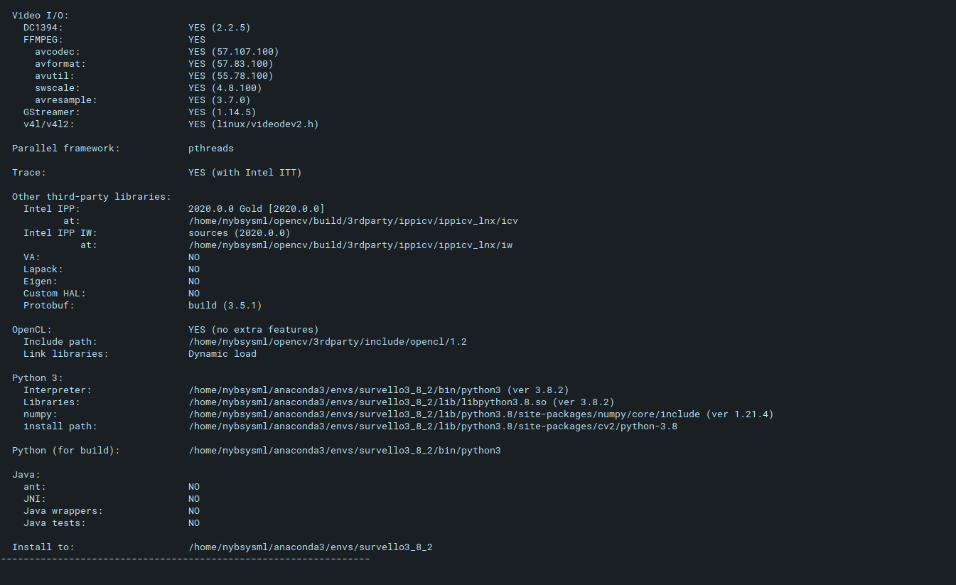

**Ref:**

**Arfan Bhai**

<https://medium.com/@arfanmahmud47/build-opencv-4-from-source-with-gstreamer-ubuntu-zorin-peppermint-c2cff5393ef>

Another Person (which suggest to git checkout another version and also using python3 in cmake command, and pip install numpy in the environment before building opencv.

<https://galaktyk.medium.com/how-to-build-opencv-with-gstreamer-b11668fa09c>